 | INVOICE  INV-2026-076

BILL TO  Swasthya Veda Healthcare (Rohit Sharma)  ROHITSHARMA7027@GMAIL.COM  6396823662  Plot no. RE 22, Sector 68, IMT Faridabad 121004 | BILL FROM  BOOSTXAI  SAURABH VASHISHTH  Adore Grand, Sector 85, Faridabad, Haryana, India, 121002  PAN: DAQPS7570L  Udyam Reg. No: UDYAM-HR-03-0152229

Invoice Date: 28 Jul 2026  Due Date: 5 Aug 2026 | Phone: +91-1293695607  Email: contact@boostxai.com  Website: www.boostxai.com

# | DESCRIPTION | QTY | UNIT PRICE (₹) | AMOUNT (₹)
1 | Meta Business Registration  Meta Business Verification  Chatbot Setup - Hosted on n8n Cloud VPS  CRM Setup - Hosted on CRM Cloud VPS  CRM Domain - https://sv.boostxai.com  Delivered on 28 Jul 2026 | Validity - 1 Year, up to 27 Jul 2027 | 1 | 12,000.00 | 12,000.00

Subtotal | ₹ 12,000.00
GST | Nil
TOTAL | ₹ 12,000.00
Amount in Words: Twelve Thousand Rupees Only
💰 PAYMENT DETAILS  Bank Name: ICICI BANK  Account No.: 140001516460  IFSC: ICIC0008035  Account Type: Savings Account  Account Holder Name: Saurabh Vashishth  Branch Name: Sec 85, Faridabad, 121002 |  | Scan to Pay via UPI  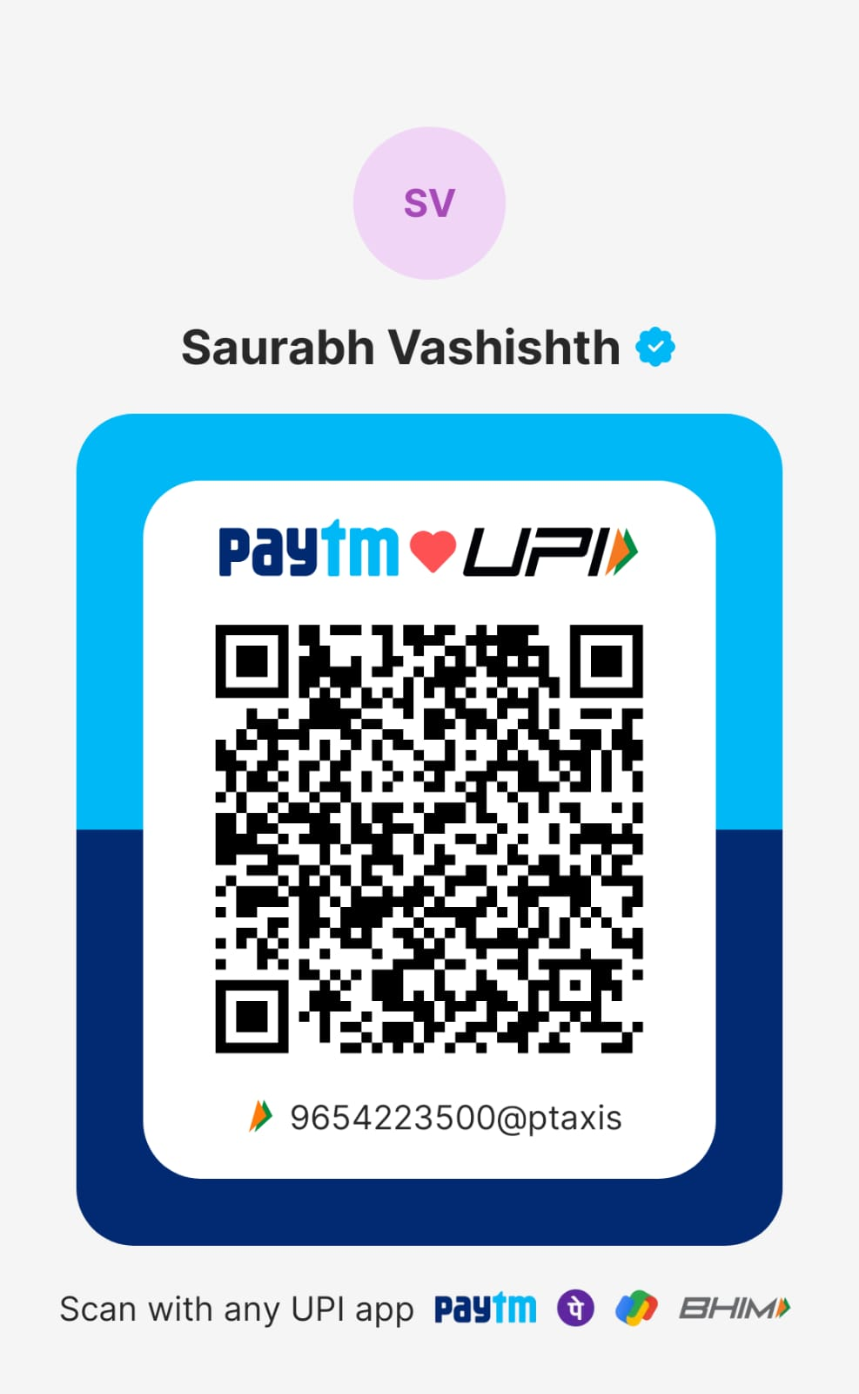  9654223500@ptaxis
For BOOSTXAI    Saurabh Vashishth  Proprietor, BoostXAI | Terms & Conditions  1. Payment is due within 7 days of the invoice date. Late payments may incur additional charges.  2. Please mention the invoice number in the payment reference/remarks.  3. For India, GST is not applicable. BoostXAI is not registered yet under GST (turnover below ₹20 lakh threshold) – India Only.  4. For Outside India, the supply of services is an export of services and is made without payment of integrated tax under the exemption for small service providers.
Thank you for your business! • contact@boostxai.com • www.boostxai.com • +91 1293695607

